M
Cold Ashby Parish Council
Annual General Meeting
Wednesday 5th May 2021

The Annual Meeting was held on Wednesday 5th May at 7.00 p.m.

Zoom Meeting
Minutes

- Election of Chairman for 2021/22: Rod Bailey
2. Apologies for Absence: all present
3. Election of other officers and representatives for 2021/22

- Vice Chairman: Neil Harpham
- 2 representatives to CAPFA committee: N Harpham; A Taylor
- 1 representative to Village Hall committee: R Bailey
- 1 internal control councillor: R Bailey

4. Review of Standing Orders: await WNC requirements. No change
5. Review of Financial Regulations and control procedures: ditto above
6. Review Risk Assessment schedule and practice: no change
7. Adoption of accounts for 2020/21: adopted unanimously
8. Appointment of Internal Auditor for 2021/22: Alan Chantler
9. Review Cemetery prices and regulations: Resolved unanimously: charges: on single and double grave purchases to be increased by £10; £5 on all other charges. (prop. Rd.W sec AP)
Regulations: regulation 12 to be amended for clarity: ‘tablets to be laid flat and flush with the ground’, and maximum size of inscription stone to be 18 x 18 inches. (Proposer RB. Sec NH).
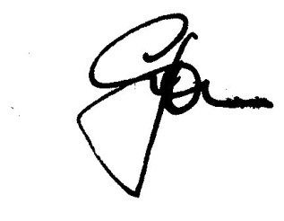
G Jones 06.05.21

https://us02web.zoom.us/j/9948519733

